<Insert title>

Project Setup

Environment Configuration

1.2 Version Control

Project Organization

2 Core Functionality

2.1 Implementation Features

2.2 Choice of Algorithms

2.3 Modular Components

3 Documentation / Implementation of Code

3.1 Example of Comments

3.2 Example of Smoke Tests

4 Unit Testing
Unit testing was used to confirm that the main game modules work correctly on their own before running the full game. We created automated tests for the core gameplay objects (Ball, Paddle, Block, and Level loading) and verified expected behavior using assertions. All unit tests are stored in the tests/ folder and can be run together to quickly confirm everything still works after changes.

4.1 Major Functionality to Test
The unit tests focus on the main gameplay behaviors that are most important to the Breakout game.
Ball (direction, movement, hitbox)
- Confirms the ball correctly scales the direction values (vx, vy) into a consistent direction.
- Confirms the ball does not get stuck when initialized with no direction (vx=0, vy=0).
- Confirms update(dt) moves the ball the correct distance over time.
- Confirms rect() returns the correct collision box around the ball.
Paddle (movement, boundaries, hitbox)
- Confirms paddle movement updates x correctly when moving left/right.
- Confirms the paddle cannot move off-screen (clamps at the left and right edges).
- Confirms rect() returns the correct collision box around the paddle.
Block (init, hit logic, hitbox)
- Confirms blocks initialize with correct position/size and settings (hp, score, color, etc.).
- Confirms rect() returns the correct collision box.
- Confirms hit() reduces HP correctly and reports when the block is destroyed.
Level (map loading, validation, conversion)
- Confirms Level.from_file() loads a JSON level file correctly (width, height, tile size, and blocks).
- Confirms invalid level data is handled correctly (ex: negative grid coordinates, invalid JSON, missing file).
- Confirms all level JSON files in the levels/asset’s directory can be loaded and converted into valid Block objects.

4.2 Unit Testing Framework
Our project uses pytest as the unit testing framework. Pytest was chosen because it runs all tests quickly in one command and gives clear pass/fail results, which makes it easy to verify the code after changes.
All unit tests are stored in the tests/ folder and follow pytest’s naming rules:
- Test files start with test_ (ex: test_ball.py, test_paddle.py, etc.)
- Test functions start with test_
Using the command:
python -m pytest -q tests
The results showed 21 tests passed successfully, confirming the tested modules (Ball, Paddle, Block, and Level loading) are working as expected.

Figure 1. Running the full unit test with pytest.
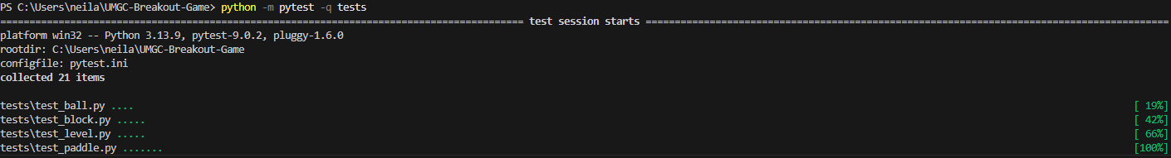

Figure 2. Pytest results showing all 21 tests passed.

5 Conclusion

